**Module 7 – Critical Thinking Assignment**

**Course Information**

Overview:

To build a python program that can do a hash map lookup across different courses and figure out the room numbers, InstructorName and Meeting time.

Principles:

* Follow a class approach so that the objects can be created later on
* Reusability – the methods should be reusable.
* Ease of use
* Reuse the class that I built in module for adding items.
* Performance – the program should do the object lookups as quick as possible (preferably O(1)).

Lessons learnt.

* Learned modular programming using classes and methods.
* Learned HashMap lookups by creating dictionaries that holds teachers information.

Challenges faced.

* Initially I was doing the code in a regular approach not following a class that is not scalable.

How I overcame the above challenges.

* By Creating classes
* The constructors class holds the static variables for RoomNUmbers, Instructors and meeting times.
* This can be scalled by hooking up to any number of data sources
* Then created getCourseInfo method to improve reusability.

Program –

Execution-

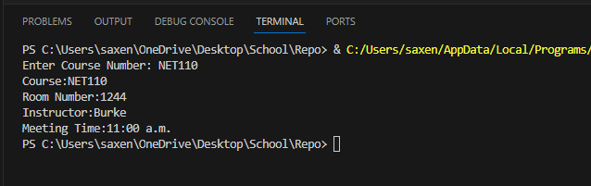

Git path - <https://github.com/ArunSaxena200/SchoolPython/blob/main/Module6_list_dictionary/PortfolioMilestone_OnlineShoppingCart.py>

Thanks,

Arun